**Assignment 1**

Name: Chethan.Y

USN: 22BTRAD011

1. Write a Scala program to print "Hello, world" and version of the Scala language.

Scala Code-1:

object HelloWorld { def main(args: Array[String]): Unit = { println("Hello, world!") println("Scala language: "+util.Properties.versionString)

Output: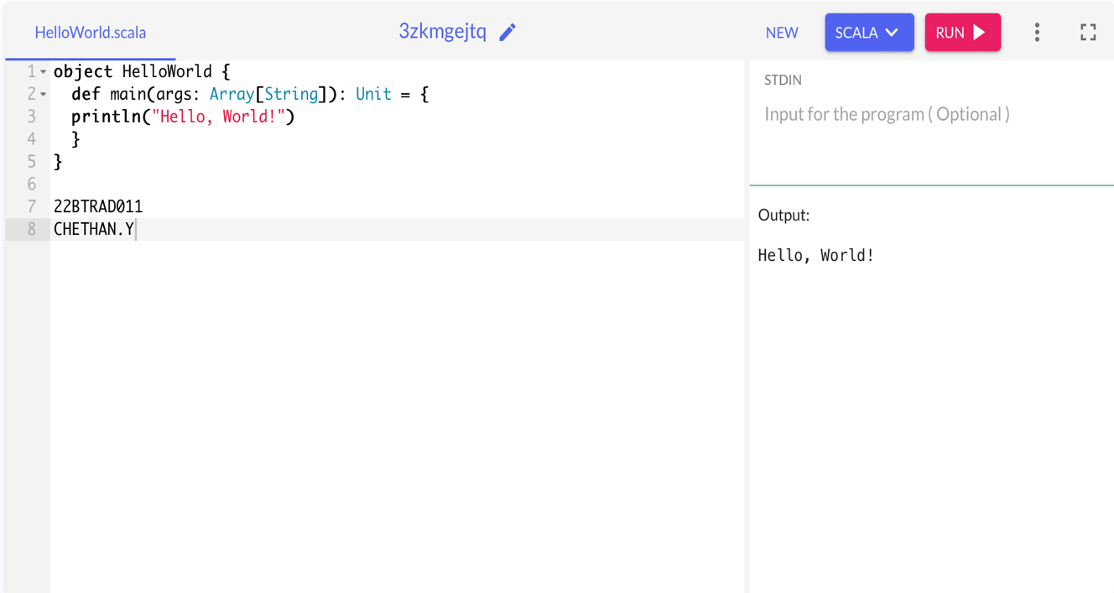

Scala Code-2:

object Hello extends App { println("Hello, world") println("Scala language: "+util.Properties.versionString)

}

Output:

